[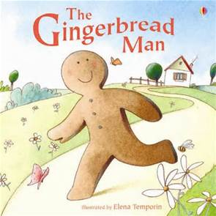](http://www.bing.com/images/search?q=gingerbread+man+story&view=detailv2&&id=94E2D8CDD373FAB5ECA429729A2D9943D76BF6CD&selectedIndex=3&ccid=e41oODJK&simid=608052097381761977&thid=OIP.M7b8d6838324a99a4c3fabce9e1558ae3H0)

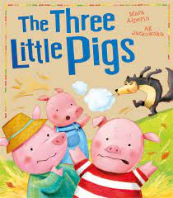[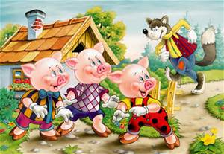](http://www.bing.com/images/search?q=three+little+pigs+story&view=detailv2&&id=0FDD1916950C00AAE0CB6307F7718CF12A9A359D&selectedIndex=1&ccid=VaYLGwf7&simid=608043700727581494&thid=OIP.M55a60b1b07fba4d110e19d1716b6ad3aH0)

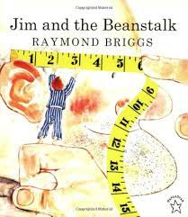

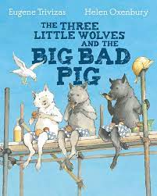

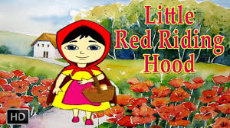

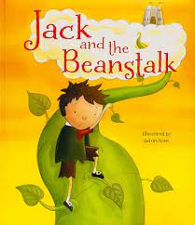

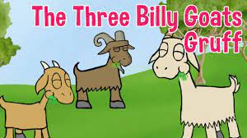

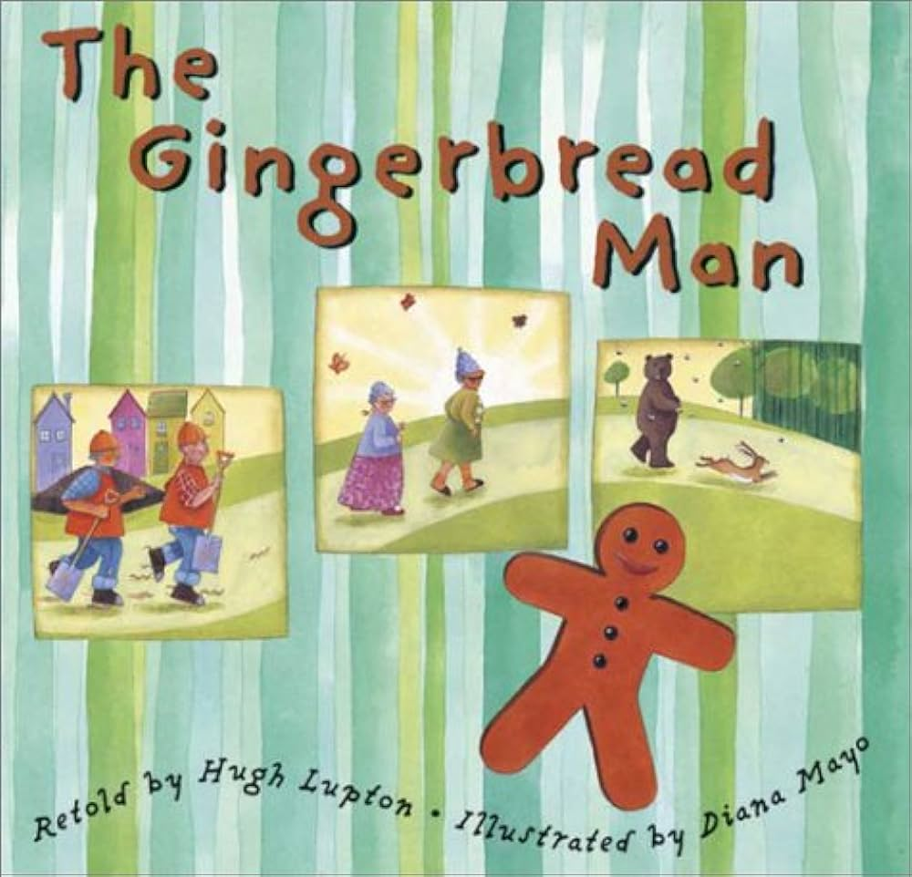

[](http://www.bing.com/images/search?q=gingerbread+man+story&view=detailv2&&id=94E2D8CDD373FAB5ECA429729A2D9943D76BF6CD&selectedIndex=3&ccid=e41oODJK&simid=608052097381761977&thid=OIP.M7b8d6838324a99a4c3fabce9e1558ae3H0)

Some of the stories we will be sharing during our theme of

***Traditional tales***