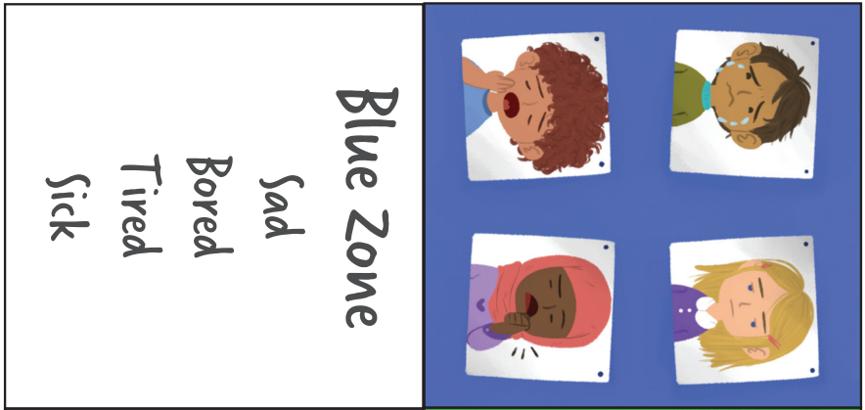

**Blue Zone**

Sad

Bored

Tired

Sick

**I am in the Blue Zone, I could…**

Think about what makes me happy.

Wibble wobble arms

Have a drink of water.

Do 15 star jumps.

Talk to someone.

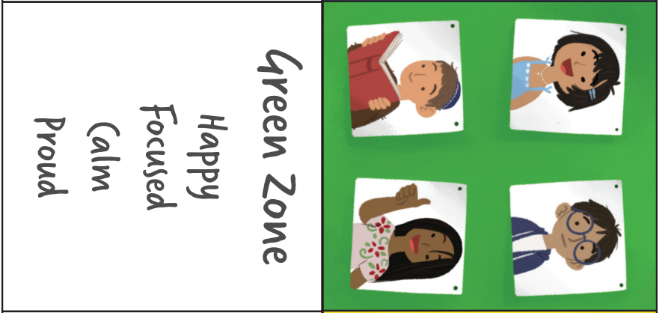

**Green Zone**

Happy

Focused

Calm

Proud

**I am in the Green Zone, I am…**

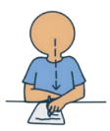

Feeling focused.

Ready to learn.

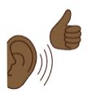

Listening well.

Able to help someone.

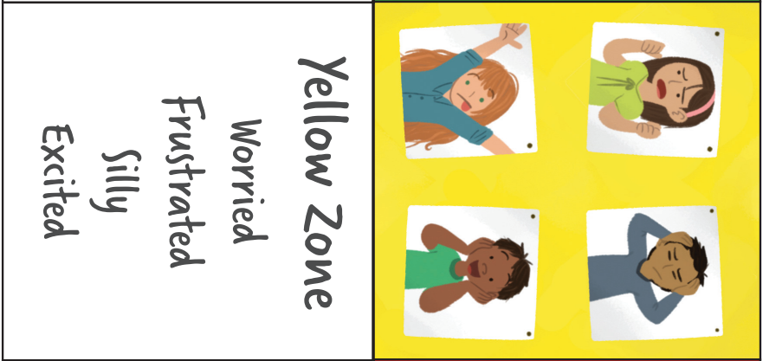

**Yellow Zone**

Worried

Frustrated

Silly

Excited

**I am in the Yellow Zone, I could…**

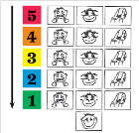

Write/draw your worries.

Talk to someone.

Do a calming sequence.

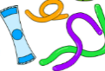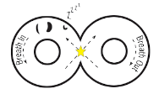

Use a fidget toy.

Lazy 8 breathing.

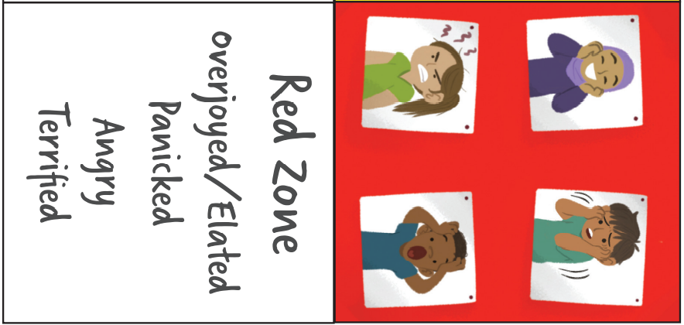

**Red Zone**

Panicked

Overjoyed

Angry

Terrified

**I am in the Red Zone, I could…**

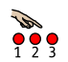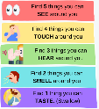

Do a calming activity.



Name/find 5 things.

Count.

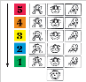

Lazy 8 breathing.

Talk to someone.

Do a calming sequence.

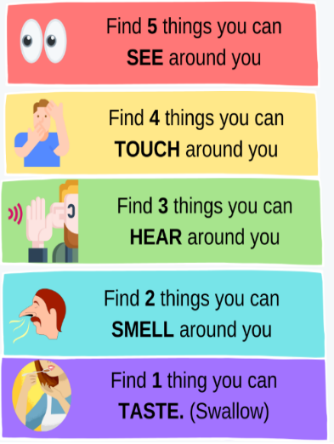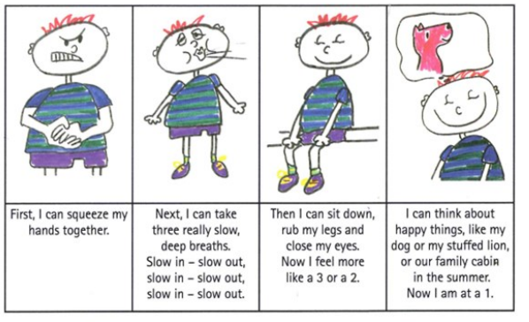

**Calming sequence - repeat**

|  |  |  |  |
| --- | --- | --- | --- |
| Squeeze hands together for 5 counts | Take slow breaths in and out x 5 | Sit down, close my eyes, rub my legs x 10 | Think about something that makes you happy. |

**Name/find 5 things.**

**Lazy 8 breathing**

