The Zones of Regulation – a guide for parents
What is it?
The Zones of Regulation is a framework to simplify how we think about and regulate our emotions. It categorises complex feelings into four zones; red, yellow, green and blue. The Zones of Regulation should be used to support your child to recognise and communicate their emotions in a safe and non-judgemental way. Parents and school can then work with them to identify and utilise specific strategies or ‘tools’ to support their regulation so they can move through the zones. Children should feel safe to communicate about their emotions, therefore no zone or emotion should be seen as ‘bad’.
The Zones of Regulation should not;
Be used as a behaviour or discipline strategy.
Be used in a negative way to shame them about how they have dealt with a situation inappropriately.
What does it look like and how can we use it?
The main model that pupils use in schools is included in the example below (your school can provide an A4 version of this for you);
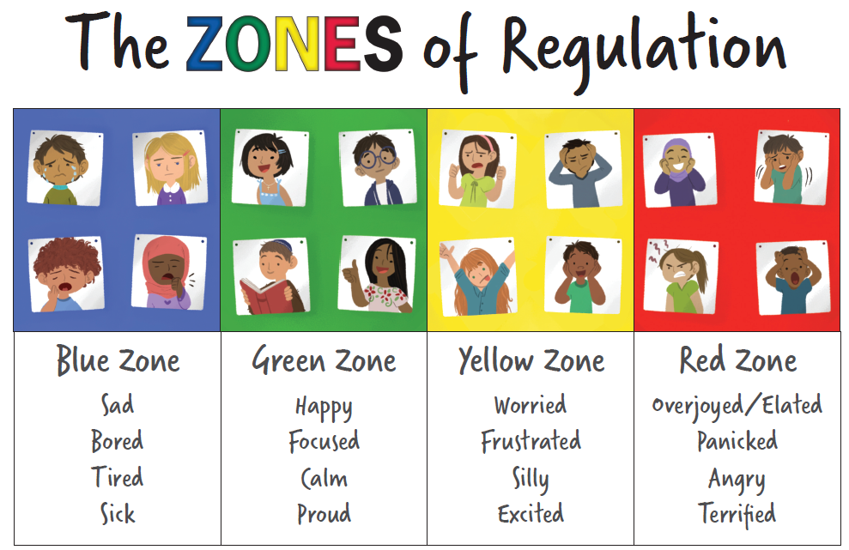
Schools will likely do some work using this model to explore your child’s individual physical response to each emotion (for example, when they are angry in the red zone their face feels hot, they clench their fists etc). School may also create an individual resource with your child to highlight strategies that they can use to support them to regulate when they are experiencing challenging emotions. Some examples of what these may look like are included below;
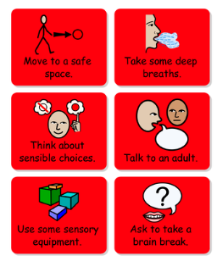
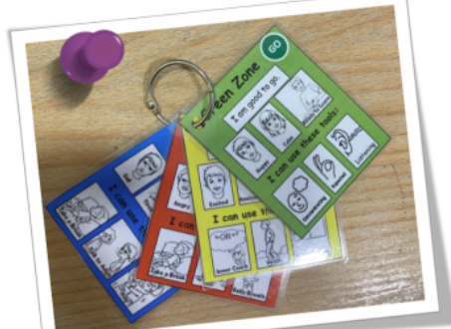
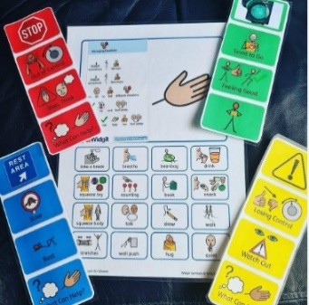

How can I help at home?
- Talk openly with your child about emotions and try to use the language included in the zones at home.
- If your child uses their own language to communicate a feeling for example, ‘I feel crazy’, help them to categorise it and add it into the Zones of Regulation’ by hand.
- Help your child to label their emotion if they are unsure.
- Support your child to find strategies to help them to regulate and move through the zones.
- Praise them for utilising appropriate strategies to help them when they are heightened and highlight their success for example, ‘You were angry in the red zone but you took a break in your room and now you seem much calmer – well done for using an appropriate strategy to help you to regulate’.
- Co-regulate with your child using specific strategies – they may need you to teach them how to use them and do it with them for some time before they begin to utilise them independently. For example, take 5 deep breaths, squeeze each hand 5 times, think of your favourite thing for 5 seconds.
- Model your own use of the zones at home for example, ‘I felt angry in the red zone when someone was rude to me in the supermarket so I took 5 deeps breaths and moved away from them and it helped me feel calmer towards the green zone’ or ‘I’m feeling frustrated in the yellow zone with all the work I have to do so I am going to ask my boss to help me’ so I can feel calmer in the green zone at work because that’s when I feel at my best’.
- If your child has struggled with their emotional regulation and not been able to utilise an appropriate strategy, use this as a learning opportunity and, when they are calmer, discuss what they could do differently next time and who can help them with this in the future.
- Share ideas around strategies that work for your child at home with your child’s class team.
- As always, discuss any successes or concerns with your child’s class team or other members of SLT.

