Sharnbrook Primary Knowledge Planner – Y2 History
Key Question: How was Earnest Shackleton’s voyage different to Matthew Hensons? |  | Similarity and difference
What I should already know | 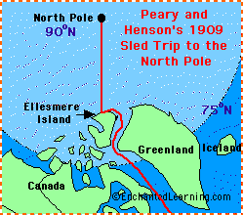  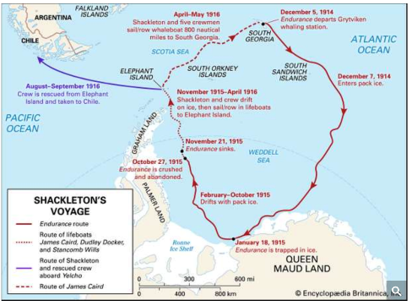  A map of Shackleton’s journey A map of Henson’s journey  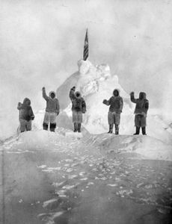  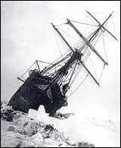  The Endurance stuck in pack ice Henson at the North Pole | Vocabulary
In Y1 the children have used first-hand accounts, photographs and books as sources of evidence. |  | South Pole The furthest you can go south on the globe.  Antarctica A continent around the South Pole.  Arctic The northern most area in the world  Endurance Shackleton’s ship.  North Pole The furthest you can go north on the globe  Frostbite Skin that has been damaged because it is so cold.  Pack ice A large piece of floating ice made up of smaller pieces being squashed together.  South Georgia A small island in the Atlantic Ocean.  Elephant Island An island off the Antarctic coast.  Lifeboat Small boats kept on a ship in case of emergencies.  Drifted Carried along by water.  Hazardous Dangerous.  Bitter Very cold.  Inuit Native people of the Arctic regions  Native People who come from that place  Similar Things that are alike but not the same
People
Earnest Shackleton
Leader of the 1914 expedition to the South Pole
Frank Wild
Second in command of the 1914 expedition to the South Pole
Matthew Henson
The first person to walk on the North Pole in 1909.
Robert Peary
The leader of the 1909 expedition to the North Pole

Timeline |  | How to be a Historian
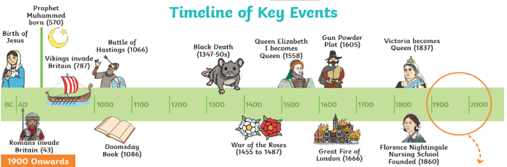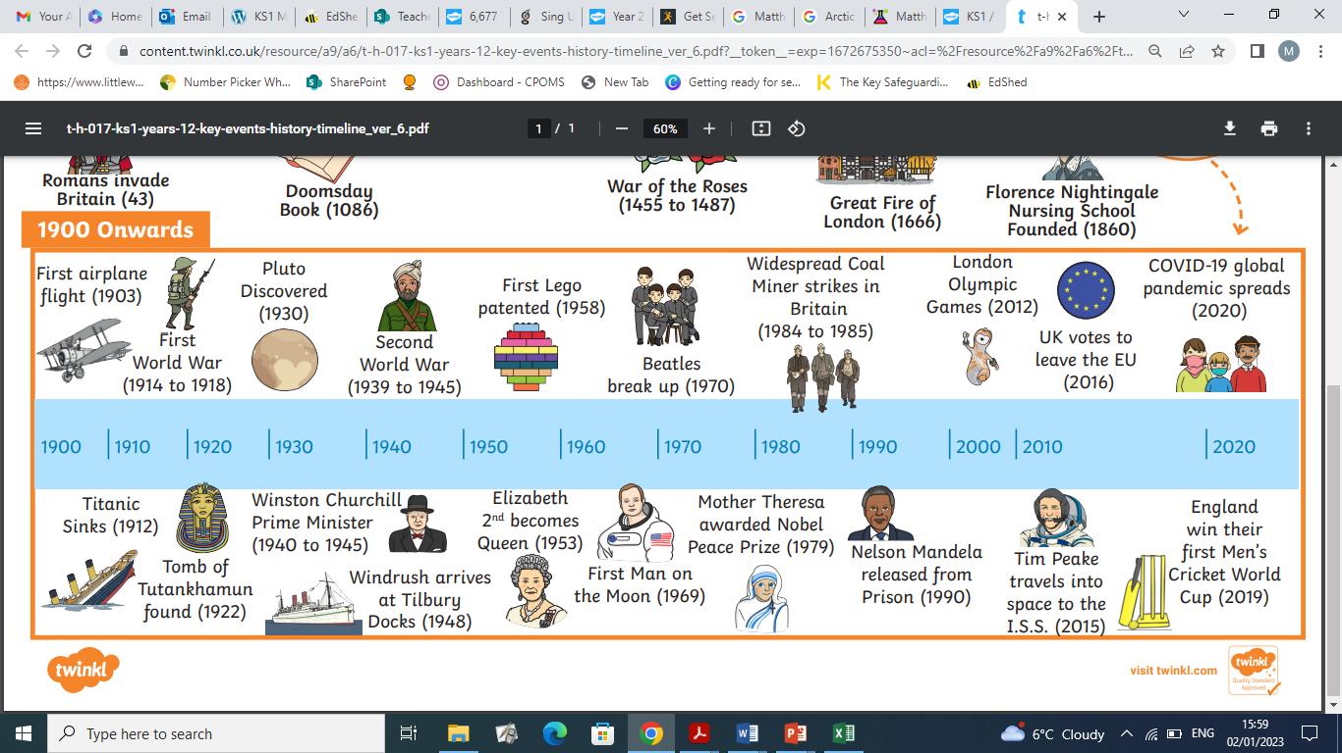 |  | - Know what happened on the two polar expeditions.  - Explain how the voyages were different  - Explain how the voyages were similar  - Start to explain the effects of the differences.

