Sharnbrook Primary Knowledge Planner – History Y3
Key Question - How different was the way of life after the Romans left? |  | Emphasis: Change and continuity
What I should already know | 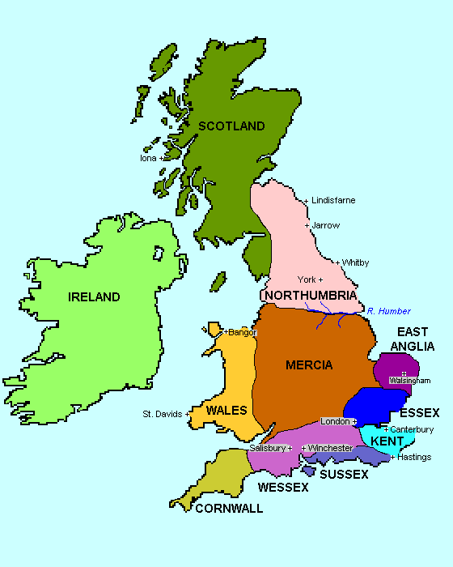  Images / maps  A map of Anglo-Saxon Britain  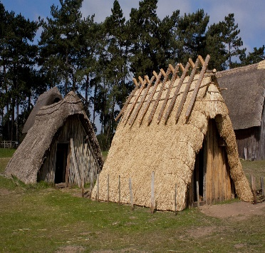  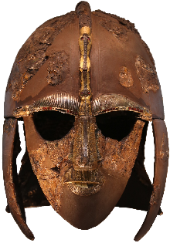  Sutton Hoo helmet  Anglo-Saxon houses | Vocabulary
What life was like in Roman Britain. (See previous knowledge organiser) |  | Change An act or process when something becomes different.  Chronology The order of events or dates when they happened.  Artefact Something that is manmade from a particular time.  King Male ruler of an area of land.  Primary Evidence Something that comes from the time being studied.  AD Anno Domini. Starts at when Christians believe Jesus was born.  Kingdom Area ruled by a king or queen.  Community Group of people living in an area.
People
Anglo-Saxons – Tribes from Germany, Holland and Denmark
Picts – Tribes from Scotland
Romans – People from Italy who ruled parts of Britain for over 400 years
Alfred the Great

 |  | How to be a historian
- Can remember what life was like in Roman Britain.
- Can remember changes that happened when the Anglo-Saxons came to Britain.
- Start to know how much was changed and how quickly.
- Using historical vocabulary where necessary.
Timeline |  | Key Knowledge
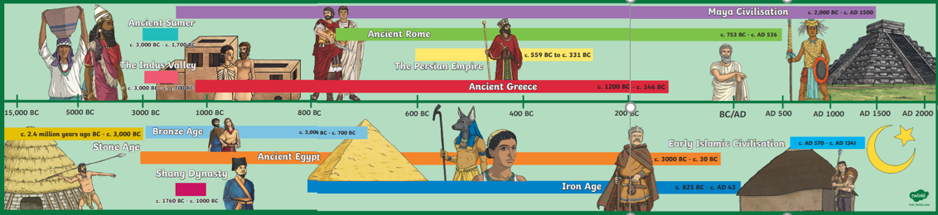 |  | Anglo-Saxons came to Britain after the fall of the Roman empire.  Anglo-Saxons lived in villages centred around a communal hall.  Anglo-Saxons ruled land differently to the Romans.

