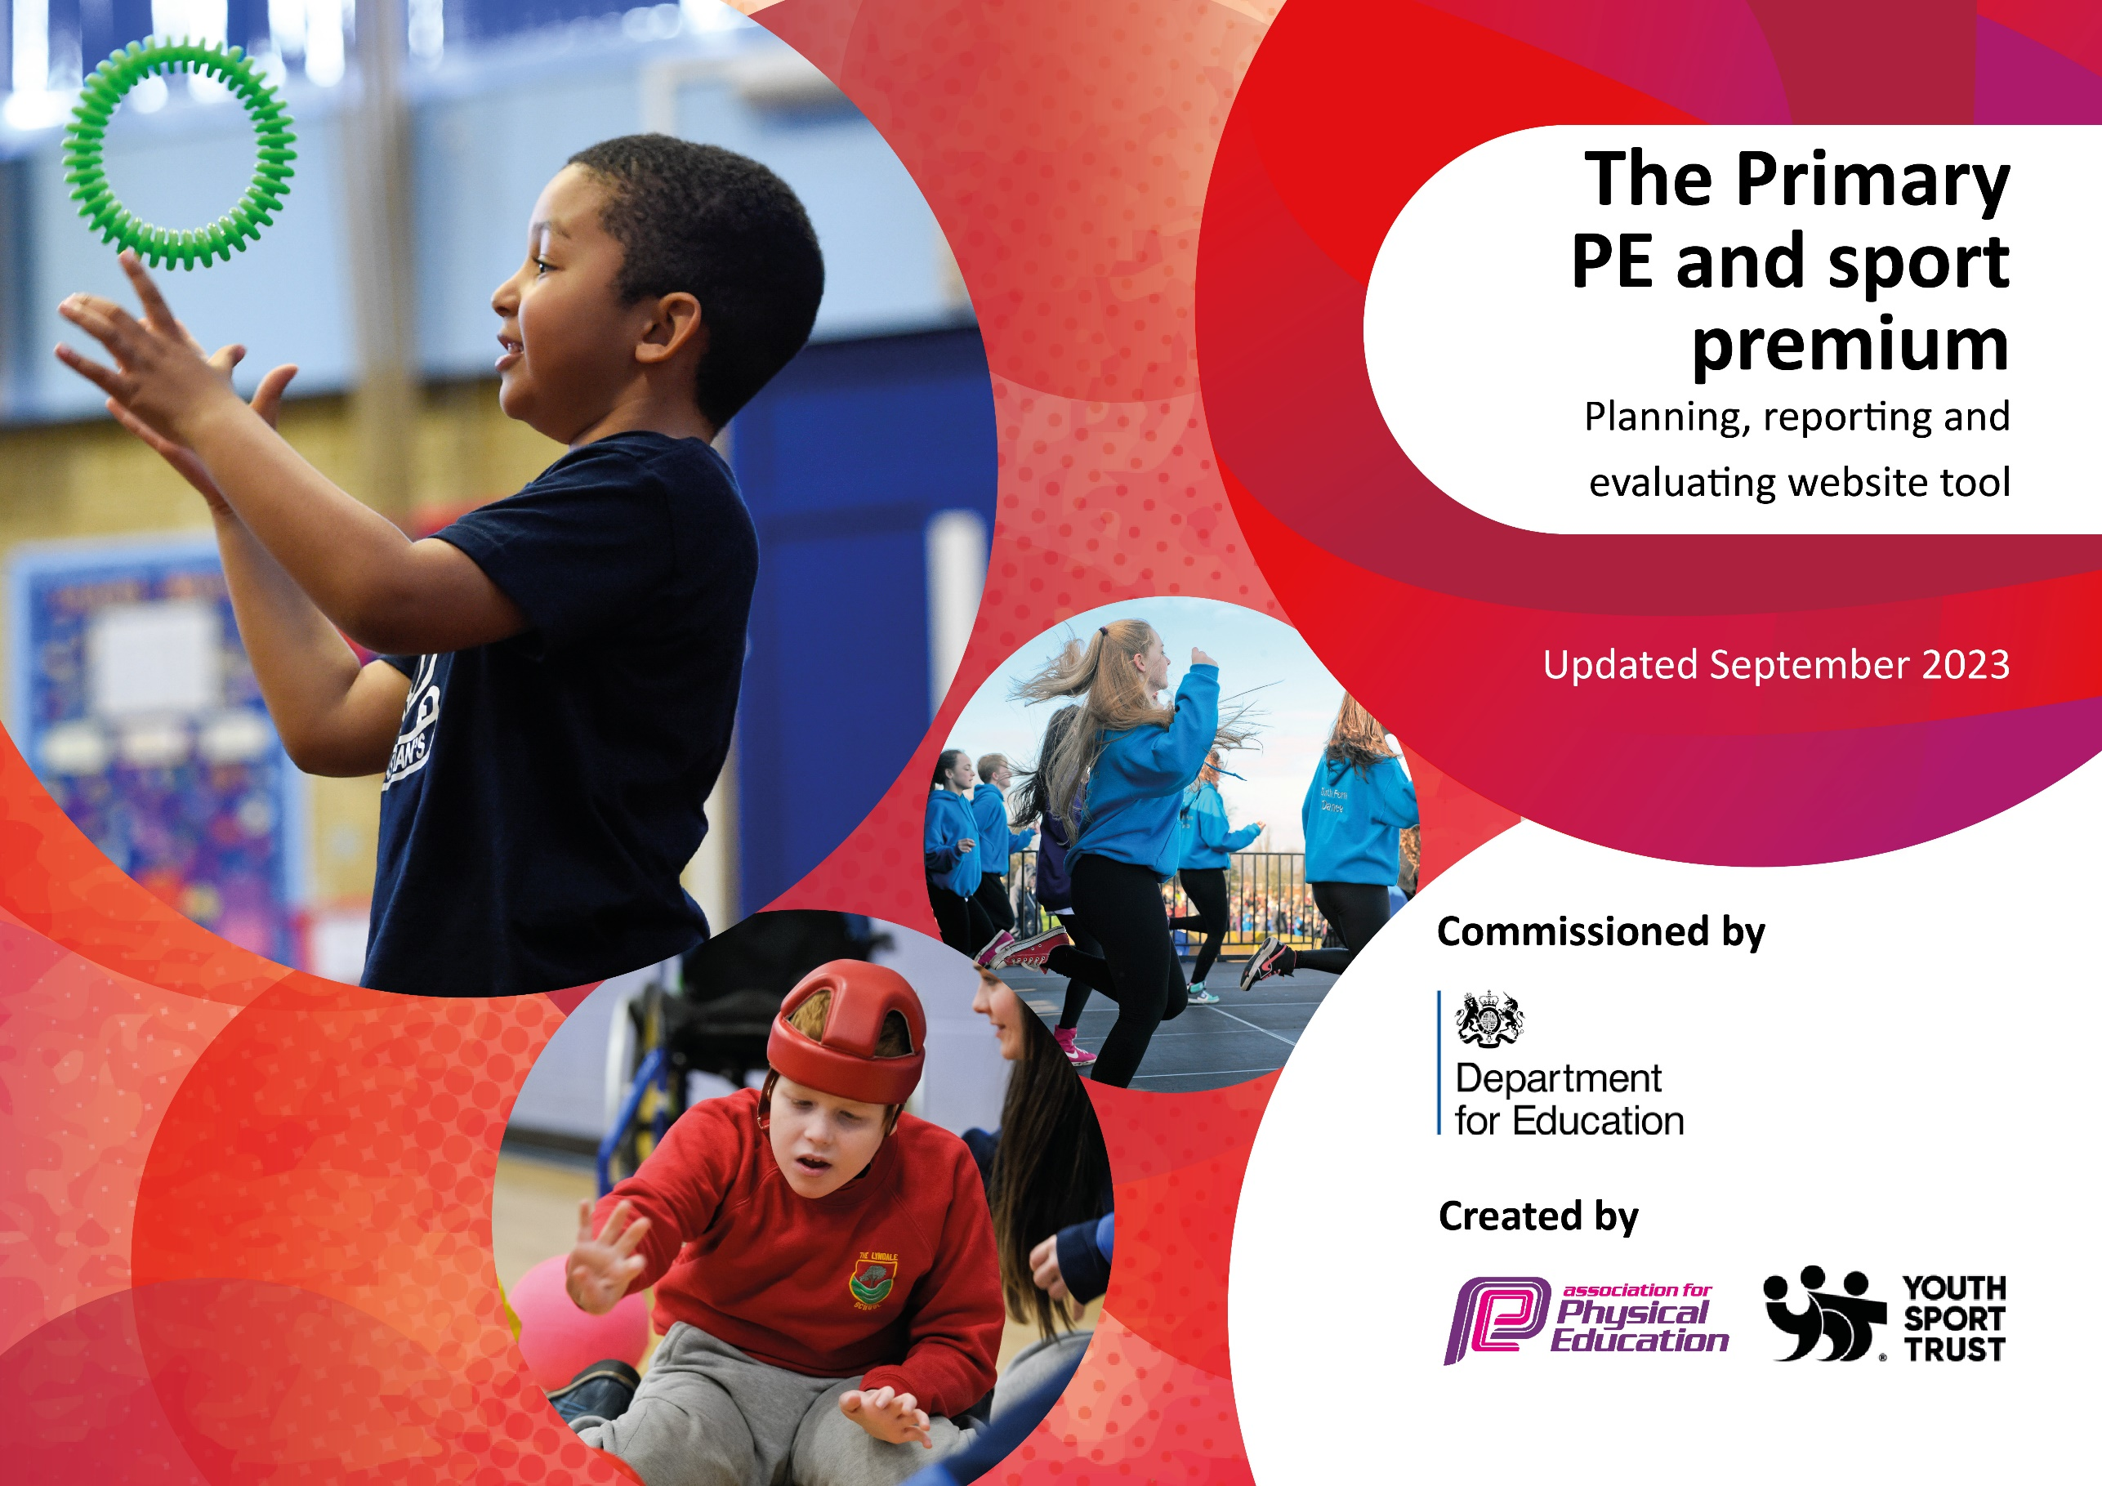

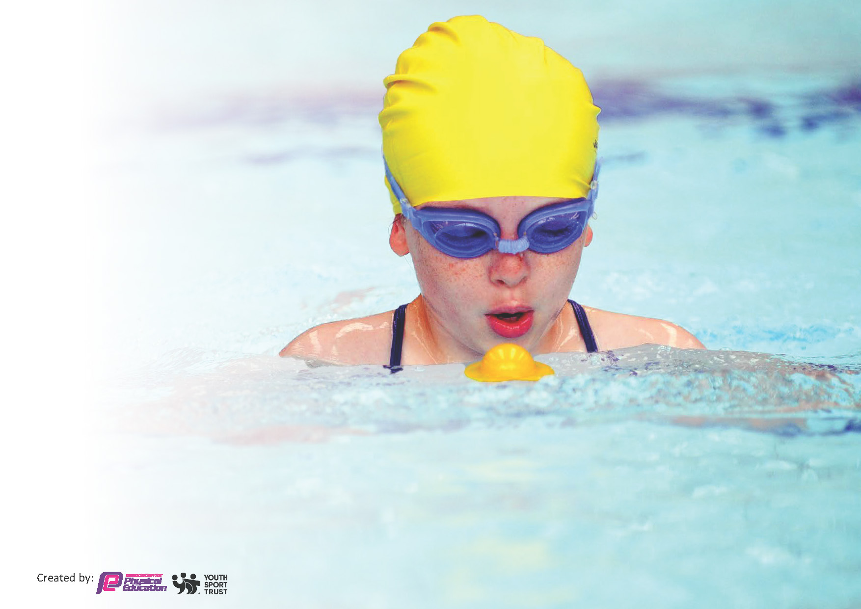
This template can be used for multiple purposes:
by:
- It enables schools to effectively plan their use of the Primary PE and sport premium
- It helps schools to meet the requirements (as set out in guidance) to publish information on their Primary PE and sport premium
- It will be an effective document to support Ofsted inspections enabling schools to evidence progress in Physical Education (PE) and evidence swimming attainment, which forms part of the PE National Curriculum. We would recommend schools consider
the Intent, Implementation and Impact of any spend, as examined within the Education Inspection Framework.

It is important that your grant is used effectively and based on school need.

Schools must use the funding to make additional and sustainable
improvements to the quality of the PE, School Sport and Physical Activity (PESSPA)
they offer. This means that you should use the Primary PE and sport premium to:

- Build capacity and capability within the school to ensure that improvements made now will benefit pupils joining the school in future years
- Develop or add to the PESSPA activities that your school already offers.

The Primary PE and sport premium should not be used to fund capital spend projects; the school’s core budget should fund these. Further detail on capital expenditure can be found in the updated Primary PE and sport premium guidance.

The Primary PE and sport premium guidance, outlines 5 key priorities that funding should be used towards. It is not

necessary that spending has to meet all the key priorities, you should select the priorities that you aim to use any funding towards.

Although completing this template is not a requirement for schools, schools are required to publish details of how they spend this funding. Schools must also outline what the impact this funding has had on pupils’ PE and sport participation and attainment and how any spending will be sustainable in the future. All funding must be spent by 31st July 2024.

The Department for Education has worked closely with the Association for Physical Education (afPE) and the Youth Sport Trust (YST) to develop this template and encourages schools to use it. This template is an effective way of meeting the reporting requirements of the Primary PE and sport premium.
Review of last year’s spend and key achievements (2022/2023)

We recommend you start by reflecting on the impact of current provision and reviewing your previous spend.

Activity/Action | Impact | Comments
- MOKI bands purchased for every child in  KS2 and school staff.  - Year 6 playleader training.  - Yoginis Yoga Gateway Training for PE staff  - Catch up swimming lessons in Summer Term 2  - To develop opportunities for cycling in school. Bikeability training booked for years 4-6. Early years using Balanceability.  - Bought into Bedfordshire School Games package.  - Yoga mats purchased for core PE lessons. | Increased levels of engagement, enthusiasm and activity for movement for all children throughout KS2 and school staff.  Increased levels of engagement, enthusiasm and activity for movement for all children throughout KS2 and school staff.  Increased levels of engagement in Yoga as using a scheme that is age appropriate for each key stage.  All children can now swim 25m and perform self-rescue.  All children will be able to ride a bike safely and confidently by the end of Year 6.  Staff gained access to gymnastics training in PE and knowledge and confidence increased.  Children could attend competitive sports events with other local schools and compete.  Extra-curricular clubs were run at lunchtime to engage all children in physical activities.  Children experienced Yoga on the correct mat, they had their own work space which allowed them to develop their practice and learning. | Children have really enjoyed the MOKI challenges and have designed their own. They enjoyed participating in competitions with other schools locally, nationally and globally!  Indicators 2, 3 and 5.  Physical activities lead by children are available for all children at break time/lunch times.  Indicators 2,3,4,5  Children have enjoyed learning about Yoga in more depth, can talk about how it affects their mind and body and can design their own sequences. Staff more confident in teaching Yoga to KS2.  Indicators 1,2,4  Indicators 2  KS2 children will all be able to participate in the mountain biking when they attend the Grafham Water residential trip.  Indicators 2,4  Children enjoy competing against other local schools.  Indicators 1,2,3,4,5  Feels an authentic yoga class now because we are using the correct equipment.  Indicators 2,3,4

Key priorities and Planning
This planning template will allow schools to accurately plan their spending.

Action – what are you planning to do | Who does this action impact? | Key indicator to meet | Impacts and how sustainability will be achieved? | Cost linked to the action
Introduce a girls’ football club at lunchtime for all ages.  Train and employ a member of staff to lead/referee lunchtime sports and activities.  Hire Pools to Schools.  To enable intensive catch up swimming throughout the whole school and ensure that every child will have the opportunity to swim competently, confidently and proficiently over a distance of at least 25 metres , use a range of strokes effectively [for example, front crawl, backstroke and breaststroke] and perform safe self-rescue in different water-based situations.  Continue to use the Cross Curricular Orienteering scheme.  Update the Cross Orienteering markers to the new scheme.  Continue to use Boxercise as a unit of PE.  Continue to teach the children to learn to ride a bike.  Continue to use MOKI bands.  Continue to use iPads in PE lessons.  Introduce French Skipping at break times and PE lessons.  Keep the PE cupboard safe, tidy and organized.  Have Playleaders at break times.  Introduce Handball as a PE unit.  Additional member of staff to teach PE.  Introduce throwing and catching skills at break times.  Introduce new activities for Sports Day.  Continue to use Moki bands with KS2.  Continue to use Moki bands with KS2.  Continue to use PE iPads.  Continue to use Moki bands with KS2.  Continue to use Moki bands with KS2.  Need new helmets for children to ride bikes. | Kelly (SGO) who will lead the club, the female pupils who wish to participate, lunchtime staff who wish to learn from Kelly leading the club.  Lunchtime staff, the children at lunchtime.  Every child in the school.  Teachers and support staff to use the lessons as CPD.  The children and staff.  Children and staff.  Bursar to purchase 30 bike helmets for children.  All children.  Bursar to purchase missing/lost straps and accelerometers and batteries.  All children in KS2.  Bursar to purchase iPad chargers.  Staff and children.  Bursar to purchase French skipping elastics.  Staff and children.  Bursar to purchase cone holders.  SGO to deliver playleader training to year 6.  Bursar to purchase handballs and handball goals. CG to deliver training on handball to the staff teaching it.  Bursar to pay for additional member of staff to teach yr5 PE lesson each week.  Bursar to purchase 60 small waterproof balls.  Bursar to purchase powerbounce mats, buckets and sponges, medals, shot puts.  Bursar to purchase 10x small Moki band straps.  Bursar to purchase 5 packs of 40 batteries.  Bursar to purchase 9xApple mains charging adapters and leads for PE iPads.  Bursar to purchase 30x small straps.  Bursar to purchase 20xsmall Moki bands.  Bursar to purchase 30xsmall/medium bike helmets. | Key indicator 1, 2, 3, 4, 5.  Key indicator 1, 2, 3, 4 and 5.  Key indicator 1, 2, 3, 4.  Key indicators 1,2,3,4,5  Key indicators 2,4  Key indicators 2,3,4  Key indicators 2,3,4,5  Key indicators 1,2  Key indicators 1,2,3,4  Key indicator 1,2,3  Key indicator 2,3,4,5  Key indicator 1,2,3,4,5  Key indicator 2  Key indicator 2,3,4,5  2,4,5  2,3,5  2,3,5  1,2  2,3,5  2,3,5  2,3,4 | More female pupils meeting their daily physical activity goal, more female pupils encouraged to take part in PE and Sport Activities.  Lunchtime staff knowledge and confidence will increase in leading a female only activity at lunchtime.  More children physically active at lunchtime. Staff more confident to lead a physical activity. Fewer arguments and falling outs on the field during physical activities.  All children will be able to swim competently, confidently and proficiently over a distance of at least 25 metres , use a range of strokes effectively [for example, front crawl, backstroke and breaststroke] and perform safe self-rescue in different water-based situations.  Staff are confident to teach OAA. Children have access to competitive OAA activities and have links across multiple subjects.  Children have access to a different sports and activities and can work on personal improvement. 2 members of staff are confident to teach Boxercise/fitness.  Children are wearing the correctly sized and fitted helmets keeping them safe whilst learning to ride.  All KS2 children can participate in the MOKI challenges. Increased motivation for movement and increased participation in physical competitive challenges.  Staff and children can ensure that iPads are charged and ready to use in PE lessons. Children can then use the iPads for assessments etc in PE lessons.  Children are active and engaged in physical activity at break times.  PE cupboard is tidy and staff can use the cones more efficiently in lessons.  Year 6 children are using their leadership skills at break times and all children have access to organized activities at lunch times.  Children are introduced to a new sport and staff are confident to teach it.  Children improve their throwing and catching skills and are active at break times.  Children to experience different sports and activities.  All KS2 children included in the Moki Band challenges.  All KS2 children included in the Moki Band challenges.  Children and staff to use PE iPads to evaluate/assess activities in PE lessons.  All KS2 children included in the Moki Band challenges.  All KS2 children included in the Moki Band challenges.  Children can ride bikes safely in school. | £0  Part of the Bedfordshire School Games package.  £0  £8000 every 4 years.  £400 for the subscription(updated schemes of work) and £160 for the updated markers.  £400  £337.99  £580  £83.29  £100  £20  £0  Part of School Games package.  £400.92  £1472  £60  £641.65  £250.00  £69.95  £83.29  £65.00  £515.00  £337.99

Key achievements 2023-2024
This template will be completed at the end of the academic year and will showcase the key achievements schools have made with their Primary PE and sport premium spending.

Activity/Action | Impact | Comments
The main action was to increase the activity levels in all children throughout the school, post covid. Moki bands were the main purchase to increase the motivation of the children to get moving and find a joy in movement. | The activity levels of all children increased. | We will continue to use the Moki bands as tool to monitor and motivate the children to increase their movement levels.

Swimming Data
Meeting National Curriculum requirements for swimming and water safety.
Priority should always be given to ensuring that pupils can perform safe self-rescue even if they do not fully meet the first two requirements of the National Curriculum programme of study

Question | Stats: | Further context  Relative to local challenges
What percentage of your current Year 6 cohort can swim competently, confidently and proficiently over a distance of at least 25 metres? | 100% | Children attended core Swimming lessons in years 3 or 4 and then those requiring catch up lessons attended again in year 5. They were taught by Level 2 swimming coaches at the local pool.
What percentage of your current Year 6 cohort can use a range of strokes effectively [for example, front crawl, backstroke, and breaststroke]? | 100% | Children attended core Swimming lessons in years 3 or 4 and then those requiring catch up lessons attended again in year 5. They were taught by Level 2 swimming coaches at the local pool. They were taught a range of strokes.

What percentage of your current Year 6 cohort are able to perform safe self-rescue in different water-based situations? | 100% | Children attended core Swimming lessons in years 3 or 4 and then those requiring catch up lessons attended again in year 5. They were taught by Level 2 swimming coaches at the local pool. They were taught to perform safe self-rescue in different water-based situations.
If your schools swimming data is below national expectation, you can choose to use the Primary PE and sport premium to provide additional top-up sessions for those pupils that did not meet National Curriculum  requirements after the completion of core lessons. Have you done this? | Yes | Children attended core Swimming lessons in years 3 or 4 and then those requiring catch up lessons attended again in year 5. They were taught by Level 2 swimming coaches at the local pool. The children in the current year 6 cohort who could not swim proficiently on leaving year 4 attended catch up swimming lessons last year(year 5) and can now all swim 25 metres.
Have you provided CPD to improve the knowledge and confidence of staff to be able to teach swimming and water safety? | Yes | The swimming lessons are taught at the local pool by qualified coaches. The staff observe these lessons and use them as their CPD. Pool staff are always available for questions at the end of the sessions. Two members of staff are level 2 qualified swimming teachers.

Signed off by:

Head Teacher: | Hannah Bennett
Subject Leader or the individual responsible for the Primary PE and sport premium: | Corinne Gingell - PE Teacher
Governor: | Mr Swan
Date: | July 2024

